Assignment 3

Amanda Bakalarczyk

2017-10-14

A)

(i)

TITLE {pqrst} (pqrst.asm)

;Stores signed and unsigned integers in double word variables, P, Q, R, S, & T.

;Five values used to solve and report the results of equations using EBX and EAX registers

;Amanda Bakalarczyk

;Assignment 3, Question A

;2017-10-11

(ii)

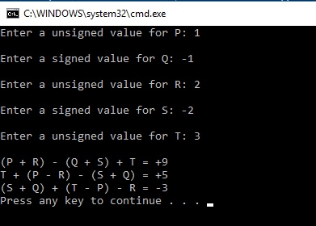

(iii)

**import** java.util.*;

**public** **class** A {

**static** **int** *p*;

**static** **int** *q*;

**static** **int** *r*;

**static** **int** *s*;

**static** **int** *t*;

**static** **int** *result1*;

**static** **int** *result2*;

**static** **int** *result3*;

**static** Scanner *input* = **new** Scanner(System.***in***);

**public** **static** **void** main(String[] args) {

System.***out***.print("Enter an unsigned value for P: ");

*p* = *input*.nextInt();

System.***out***.print("Enter a signed value for Q: ");

*q* = *input*.nextInt();

System.***out***.print("Enter an unsigned value for R: ");

*r* = *input*.nextInt();

System.***out***.print("Enter a signed value for S: ");

*s* = *input*.nextInt();

System.***out***.print("Enter an unsigned value for T: ");

*t* = *input*.nextInt();

*result1* = (*p* + *r*) - (*q* + *s*) + *t*;

*result2* = *t* + (*p* - *r*) - (*s* + *q*);

*result3* = (*s* + *q*) + (*t* - *p*) - *r*;

System.***out***.println();

System.***out***.println("(P + R) - (Q + S) + T = " + *result1*);

System.***out***.println("T + (P - R) - (S + Q) = " + *result2*);

System.***out***.println("(S + Q) + (T - P) - R = " + *result3*);

}

}

B)

(i)

TITLE {DistanceDriven} (DistanceDriven.asm)

;Assignment 3, Question B

;Amanda Bakalarczyk

;2017-10-11

;Program asks the user for their average driving speed and

;minimum and maximum hours driving. Using these numbers, creates a table which

;shows how far the user will travel for each of the hours between the minimum to the maximum.

(ii)

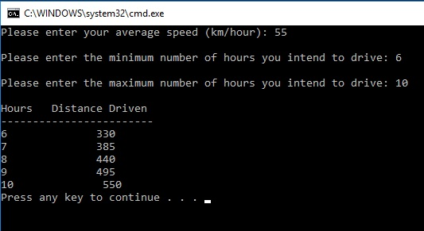

(iii)

**import** java.util.*;

**public** **class** B {

**static** **int** *speed*;

**static** **int** *min*;

**static** **int** *max*;

**static** **int** *distance*;

**static** Scanner *input* = **new** Scanner(System.***in***);

**public** **static** **void** main(String[] args) {

System.***out***.print("Please enter your average speed (km/hour): ");

*speed* = *input*.nextInt();

System.***out***.print("Please enter the minimum number of hours you intend to drive: ");

*min* = *input*.nextInt();

System.***out***.print("Please enter the maximum number of hours you intend to drive: ");

*max* = *input*.nextInt();

System.***out***.println();

System.***out***.printf("%-8s%-8s\n", "Hours", "Distance Driven");

System.***out***.println("-----------------------");

**for** (**int** i = *min*; i <= *max*; i++) {

*distance* = *speed* * i;

System.***out***.printf("%-4d%11d\n", i, *distance*);

}

}

C)

(i)

TITLE {NumberSequence} (NumberSequence.asm)

;Assignment 3, Question C

;Amanda Bakalarczyk

;2017-10-14

;Program calculates a number sequence described by the formula

;F(n) = F(n-1) * 2 + Fib(n-4) for n >=5

; Almost does what it's supposed to...

(ii)

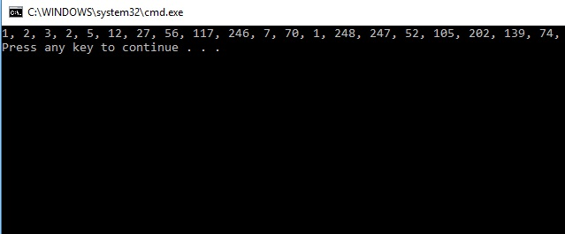

(iii)

**import** java.util.*;

**public** **class** C {

**static** **int** *f1* = 1;

**static** **int** *f2* = 2;

**static** **int** *f3* = 3;

**static** **int** *f4* = 2;

**static** **int** *fn* = 5;

**static** ArrayList<Integer> *al* = **new** ArrayList<Integer>();

**public** **static** **void** main(String[] args) {

*al*.add(1);

*al*.add(2);

*al*.add(3);

*al*.add(2);

**for** (**int** i = 4; i < 24; i++) {

*al*.add((*al*.get(i - 1) * 2) + *al*.get(i - 4));

}

**for** (**int** i = 0; i < 20; i++) {

System.***out***.print(*al*.get(i) + ", ");

}

}

}

D)

(i)

TITLE {FiveElementArray} (FiveElementArray.asm)

;Assignment 3, Question D

;Amanda Bakalarczyk

;2017-10-13

;Display the items as signed integer values, hex values

(ii)

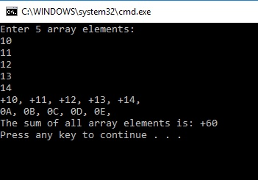

(iii)

**import** java.util.*;

**public** **class** D {

**static** **byte**[] *array* = **new** **byte**[5];

**static** **int** *total*;

**static** Scanner *input* = **new** Scanner(System.***in***);

**public** **static** **void** main(String[] args) {

System.***out***.print("Enter the array values: ");

**for** (**int** i = 0; i < *array*.length; i++) {

*array*[i] = *input*.nextByte();

*total* += *array*[i];

}

**for** (**int** i = 0; i < *array*.length; i++) {

System.***out***.printf("%d%s", *array*[i], ", ");

}

System.***out***.println();

**for** (**int** i = 0; i < *array*.length; i++) {

System.***out***.printf("%02x%s", *array*[i], ", ");

}

System.***out***.println();

System.***out***.println("Total: " + *total*);

}

}